Document for Lab 5
Course Title: Artificial Intelligence Laboratory/Project
Course Code: 0714 02 CSE 3202
Title: Autonomous Bio-hazard Collection Robot Simulation

Submitted to:
Dr. Amit Kumar Mondal
Associate Professor
CSE Discipline
Khulna University, Khulna.

Submitted by:
Sohana Rahman Tuly
Student ID: 230217
3rd Year 1st Term
CSE Discipline
Khulna University, Khulna.

Date:
Contents
Introduction 3
Problem Statement 3
System Objectives 3
System Overview & Environment Design 3
data structures 4
Algorithm 5
Pseudo-code 6
Robot Visualization and Animation 6
Performance Analysis 7
Test Cases 8

Introduction
This project presents a Robotics Simulation System designed to operate within a 500 × 500 grid-based campus environment. The primary objective of the robot is the efficient identification and collection of bio-hazards while maintaining safety protocols regarding human encounters.

Problem Statement
In a large-scale environment, manual cleanup of hazardous materials is both dangerous and inefficient. An automated system must be able to:
- Navigate through a coordinate system while avoiding static obstacles (non-accessible areas).
- Perceive its surroundings to identify targets (bio-hazards) and obstacles (humans, buildings etc.).
- Optimize its path to ensure high collection efficiency, measured by the ratio of objects collected to total moves made.

System Objectives
The simulation is built on a modular Python architecture. The environment is dynamically generated with specific densities of humans and bio-hazards to test the robustness of the robot's decision-making policy.

System Overview & Environment Design
1. System Architecture: The system follows a modular design to separate the physical world (Environment) from the "brain" (Policy).
- Environment Module (environment.py): It generates the grid, places obstacles, and manages the state of all objects.
- Robot Module (robo_sys.py): The autonomous agent.
- Policy Module (policy.py): The decision-making engine that processes sensor data to choose the next optimal action.
- Performance Module (performance.py): An analytical layer that tracks metrics like efficiency .
2. Environment Design: The simulation space is modeled as a 2D Cartesian grid. By default, it is a 500 × 500 matrix, providing 250,000 discrete cells for the robot to navigate.

Object Representation: The environment uses a numerical mapping (stored in the HazzardObject class) to represent different entities. This allows the robot to use efficient NumPy operations to "see" the world:
Entity | Value
Accessible | 0
Non-accessible | -1
Bio-hazard | 1
Human | 2

3. Obstacle Generation: Non-accessible areas are not random, they are defined as rectangular blocks to simulate a realistic building layout. To test the robot’s efficiency, the environment is populated with a high density of hazards and humans:
4. Perception and Boundaries: The environment provides a Local Perception model. The robot does not have a "god-view" of the entire map at once; instead, it queries the environment for:
- Adjacent Accessibility: Can I move UP, DOWN, LEFT, or RIGHT?
- Target Proximity: Is there a hazard at my current (x, y)?
- Safety Checks: Is there a human in the immediate 1-cell radius?

data structures
The robot simulation employs several data structures to efficiently store and manage information related to the environment, robot state, and actions:
- Numpy Array (np.ndarray): The environment grid (Environment.campus) is implemented as a 2D array of integers (np.ndarray). It stores the status of each cell, indicating whether it is accessible, non-accessible, contains a biohazard, has a human, or has been cleaned.
- Dictionary: Dictionaries are used to store structured information, such as non_accessible_info, which contains the coordinates and sizes of obstacles, and percept_history, which records the robot’s sequence of states, actions, rewards, and next states.
- List: Lists are used for ordered collections, including move_history, which stores the sequence of movement actions, collected_objects, which stores the coordinates of collected biohazard objects, and temporary lists used for accessible cells during placement of humans or biohazards.
- Set: Sets are used to store unique elements, such as visited, which contains the coordinates of cells that the robot has visited.
- Tuple: Tuples are used to represent immutable coordinate pairs (x, y) and movement vectors.
- Custom Classes: Custom classes, including Robot, Environment, HazzardObject, coordinate, Move, and Performance, are used to encapsulate data and behavior together.

Algorithm
1. Environment Initialization: A grid (size x size) is created to represent the campus. Cell types are defined: accessible (0), non-accessible (-1), bio_hazard (1), human (2) and cleaned (0). Non-accessible areas are added based on predefined coordinates and dimensions. The grid is populated with: 1. Biohazard objects, which are placed randomly in accessible cells, 2. Humans, which are placed randomly in accessible cells.
2. Robot Initialization: The robot is placed on a randomly selected accessible cell. The following are initialized:
- Position and start coordinate.
- Visited cells set.
- Counters for actions (movement, cleaning, human encounters, accessibility/biohazard checks).
- Move history.
- Collected objects list.
An initial perception check is performed to detect any biohazards at the starting cell.
3. Perception: At each cell, the following is checked:
- If a biohazard is present, it is collected and the cell is marked as cleaned.
- A biohazard check is recorded.
Optionally, perception can be extended to detect humans, obstacles, or other objects.
4. Movement: For a fixed number of steps:
- An action (UP, DOWN, LEFT, RIGHT) is determined using the policy module.
- New coordinates are calculated based on the action.
- The move is checked for validity:
  - The cell must be accessible.
  - Revisiting of cells is avoided unless allowed.
- The position is updated if the move is allowed.
- The cell is marked as visited.
- The movement action counter is incremented.
- Perception is performed at the new position.
Each action is recorded in the robot’s move history.
5. Object Collection: When a biohazard is detected: The cell is added to the collected objects list, marked as cleaned and cleaning actions counter is incremented.
6. Performance Tracking: After the simulation, metrics are calculated: Collected objects (Number of biohazards collected), Efficiency (Objects collected per movement action), Human percentage (Humans present / total accessible cells) and Total actions (Sum of movement, cleaning, and checks.). A performance report is printed.

Pseudo-code
Environment is initialized with grid size and biohazard count
Non-accessible areas are added
Biohazard objects are placed randomly
Humans are placed randomly
Robot is initialized
Random accessible start position is chosen
Start cell is marked as visited
Perception is performed at start
For each step in total_steps:
Action is determined using policy
New coordinates are calculated based on action
If move is allowed:
Position is updated
Cell is marked as visited
Movement counter is incremented
Perception is performed to check for biohazards
Action is recorded in move_history
After simulation:
Performance metrics are calculated:
Efficiency is calculated as collected_objects / total_moves
Human percentage is calculated as total_humans / total_accessible_cells
Performance report is printed

Robot Visualization and Animation
The “RobotVisualizer” class provides a real-time graphical representation of the robot’s movement using “Matplotlib”. It displays the environment grid, the robot’s current position (red circle), and visited cells (white dots). Interactive Start and Stop buttons allow control of the animation. The visualizer reads the robot’s internal data structures (campus, position, visited) to reflect the current state and advances the robot using drive_one_step(). This module integrates seamlessly with the main simulation to provide an intuitive visualization of the robot’s operation.
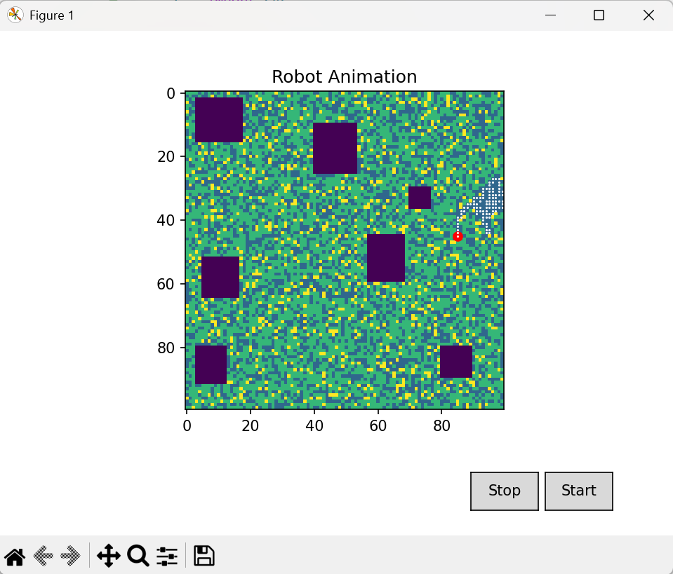
100 x 100 Grid

Performance Analysis
The robot simulation was executed for three independent runs, each starting from a different position in the campus environment. The performance metrics were collected to evaluate the effectiveness of the algorithm in terms of object collection, movement efficiency, human interaction, and overall operational actions.
Summary of Simulation Runs
Run | Start Position | Final Position | Visited Cells | Collected Objects | Movement Actions | Cleaning Actions | Human Encounters | Accessibility Checks | Biohazard Checks
1 | (28, 370) | (499, 483) | 3253 | 2644 | 5000 | 2644 | 1273 | 9104 | 5001
2 | (465, 145) | (449, 403) | 3149 | 2557 | 5000 | 2557 | 1442 | 9296 | 5001
3 | (444, 143) | (498, 261) | 2632 | 2046 | 5000 | 2046 | 1198 | 10324 | 5001

Calculated Performance Metrics
Run | Total Actions | Efficiency (Objects per Move) | Total Humans | Total Accessible Points | Human Percentage
1 | 21749 | 52.88% | 17182 | 84423 | 20.35%
2 | 21854 | 51.14% | 22271 | 79247 | 28.10%
3 | 22371 | 40.92% | 16801 | 84206 | 19.95%

Test Cases
1. Test Cases for test_environment.py:
Test Case ID | Test Function Name | Test Objective | Test Steps & Input Data | Expected Result | Status
TC-01 | test_environment_initialization() | Verify environment grid is initialized correctly. | 1. Create environment of size 50×50 with 100 biohazards. | env.campus.shape equals (50, 50) | Pass
TC-02 | test_non_accessible_generation() | Ensure non-accessible positions are generated. | 1. Create environment of size 100×100 with 0 biohazards. 2. Get non-accessible positions. | Number of obstacles > 0 | Pass
TC-03 | test_bio_hazard_generation() | Verify correct number of biohazards are generated. | 1. Create environment of size 50×50 with 200 biohazards. 2. Get biohazard positions. | Number of hazards = 200 | Pass
TC-04 | test_human_generation() | Ensure humans are generated in the environment. | 1. Create environment of size 50×50 with 0 biohazards. 2. Get human positions. | Number of humans > 0 | Pass
TC-05 | test_is_accessible() | Verify accessibility check for a cell. | 1. Create environment of size 20×20 with 0 biohazards. 2. Check if cell (0,0) is accessible. | Result is True or False | Pass
TC-06 | test_has_bio_hazard() | Check if a cell contains a biohazard. | 1. Create environment of size 20×20 with 10 biohazards. 2. Pick first hazard position (x,y). 3. Call has_bio_hazard(x, y). | Returns True | Pass
TC-07 | test_has_human() | Check if a cell contains a human. | 1. Create environment of size 20×20 with 0 biohazards. 2. Pick first human position (x,y). 3. Call has_human(x, y). | Returns True | Pass
TC-08 | test_set_and_get_cell_value() | Verify setting and retrieving a cell value works. | 1. Create environment of size 10×10. 2. Set cell (1,1) to HazzardObject.bio_hazard. 3. Get cell value (1,1). | Returns HazzardObject.bio_hazard | Pass
TC-09 | test_get_accessible_positions() | Ensure accessible positions can be retrieved. | 1. Create environment of size 20×20 with 0 biohazards. 2. Get accessible positions. | Number of accessible positions > 0 | Pass
TC-10 | test_move_direction_vector() | Verify correct vector for a given direction. | 1. Call Move.get_direction_vector("RIGHT"). | Returns (1, 0) | Pass
TC-11 | test_get_all_directions() | Ensure all movement directions are returned. | 1. Call Move.get_all_directions(). | Returns list of length 4 | Pass
TC-12 | test_transition_save_sequence() | Check transition sequence is saved correctly. | 1. Initialize Transition. 2. Save sequence ("s1","a1",1,"s2"). 3. Get percept history. | Length of history = 1 | Pass
TC-13 | test_transition_clear_history() | Verify transition history can be cleared. | 1. Initialize Transition. 2. Save sequence ("s1","a1",1,"s2"). 3. Clear history. 4. Get percept history. | Length of history = 0 | Pass

2. Test cases for robo_sys.py:
Test Case ID | Test Function Name | Test Objective | Test Steps & Input Data | Expected Result | Status
TC-01 | test_robot_initial_position_accessible() | Verify robot starts on an accessible cell. | 1. Initialize Robot. 2. Get robot’s starting coordinates (x, y). 3. Check if cell is accessible. | Robot’s start position is accessible | Pass
TC-02 | test_robot_initial_visited_contains_start() | Ensure robot’s visited set includes the starting position. | 1. Initialize Robot. 2. Check if robot.start is in robot.visited. | True | Pass
TC-03 | test_collect_action_cleans_cell() | Verify collecting a biohazard marks the cell as cleaned and updates collected objects. | 1. Initialize Robot. 2. Force a biohazard at current position. 3. Call robot.collect_action(). | Current cell is added to collected_objects | Pass
TC-04 | test_movement_updates_position() | Ensure robot’s position updates after a move. | 1. Initialize Robot. 2. Record old position. 3. Call robot.drive_one_step(0). 4. Get new position. | Old and new positions are different | Pass
TC-05 | test_visited_updates_after_move() | Verify visited cells update after a move. | 1. Initialize Robot. 2. Call robot.drive_one_step(0). 3. Get new position. | New position is in robot.visited | Pass
TC-06 | test_cleaning_action_counter() | Ensure cleaning actions counter increments after collecting a hazard. | 1. Initialize Robot. 2. Force a biohazard at current position. 3. Call robot.collect_action(). | robot.cleaning_actions increments by 1 | Pass
TC-07 | test_movement_action_counter() | Verify movement actions counter updates after a move. | 1. Initialize Robot. 2. Call robot.drive_one_step(0). | robot.movement_actions ≥ 0 | Pass
TC-08 | test_perception_increases_check_counter() | Ensure biohazard perception increases the check counter. | 1. Initialize Robot. 2. Record initial biohazard_checks. 3. Call robot.perception(). | biohazard_checks increments by 1 | Pass

3. Test cases for policy.py:
Test Case ID | Test Function Name | Test Objective | Test Steps & Input Data | Expected Result | Status
TC-01 | test_get_random_move() | Verify random move returns a valid direction. | 1. Initialize Policy. 2. Call getRandomMove(). | Returns one of ["UP", "DOWN", "LEFT", "RIGHT"] | Pass
TC-02 | test_obstacle_avoidance_unvisited() | Check obstacle avoidance when unvisited cells are available. | 1. Initialize DummyRobot at (2,2). 2. Call obstacle_avoidance(robot). | Returns a valid move ["UP", "DOWN", "LEFT", "RIGHT"] | Pass
TC-03 | test_obstacle_avoidance_visited() | Check obstacle avoidance when surrounding cells are visited. | 1. Initialize DummyRobot at (2,2). 2. Mark surrounding cells as visited. 3. Call obstacle_avoidance(robot). | Returns a valid move ["UP", "DOWN", "LEFT", "RIGHT"] | Pass
TC-04 | test_shortest_path_to_hazard() | Verify robot selects shortest path to nearest hazard. | 1. Initialize DummyRobot at (0,0) with hazard at (1,0). 2. Call shortest_path(robot, current_step=0). | Returns "RIGHT" | Pass
TC-05 | test_shortest_path_no_hazard() | Ensure robot returns a default move if no hazards are present. | 1. Initialize DummyRobot at (0,0) with no hazards. 2. Call shortest_path(robot, current_step=0). | Returns a valid move ["UP", "DOWN", "LEFT", "RIGHT"] | Pass
TC-06 | test_get_action_human_nearby() | Verify robot moves toward nearest hazard even if human is nearby. | 1. Initialize DummyRobot at (0,0) with hazard at (1,0) and human at (0,1). 2. Call get_action(robot, current_step=0). | Returns "RIGHT" | Pass
TC-07 | test_get_action_default_move() | Ensure robot returns default move when no hazards or humans are nearby. | 1. Initialize DummyRobot at (0,0) with empty environment. 2. Call get_action(robot, current_step=0). | Returns a valid move ["UP", "DOWN", "LEFT", "RIGHT"] | Pass

4. Test cases for performance.py:
Test Case ID | Test Function Name | Test Objective | Test Steps & Input Data | Expected Result | Status
TC-01 | test_efficiency_calculation() | Verify that efficiency is calculated and printed. | 1. Initialize DummyRobot with collected objects, movement actions, and cleaning actions. 2. Initialize Performance with robot. 3. Call perf.calculate(). | Output contains "Efficiency" | Pass
TC-02 | test_collected_objects_output() | Ensure collected objects count is printed correctly. | 1. Initialize DummyRobot. 2. Initialize Performance. 3. Call perf.calculate(). | Output contains "Collected objects: 3" | Pass
TC-03 | test_total_actions_output() | Verify total actions are calculated and printed correctly. | 1. Initialize DummyRobot. 2. Initialize Performance. 3. Call perf.calculate(). | Output contains "Total actions: 20" | Pass
TC-04 | test_total_moves_output() | Ensure total moves are printed correctly. | 1. Initialize DummyRobot. 2. Initialize Performance. 3. Call perf.calculate(). | Output contains "Total moves: 10" | Pass
TC-05 | test_human_percentage_output() | Verify human percentage is calculated and printed. | 1. Initialize DummyRobot with DummyEnvironment returning human positions. 2. Initialize Performance. 3. Call perf.calculate(). | Output contains "Human percentage" | Pass
TC-06 | test_zero_movement_efficiency() | Ensure efficiency is 0% when movement actions are zero. | 1. Initialize DummyRobot with movement_actions=0. 2. Initialize Performance. 3. Call perf.calculate(). | Output contains "0.0000%" | Pass

